Hickory Valley Christian School
K3 Program
By: Mrs. Kelsey Johns
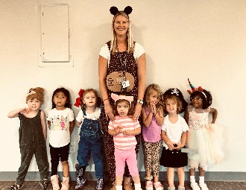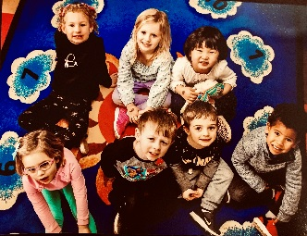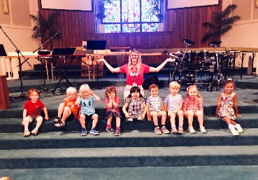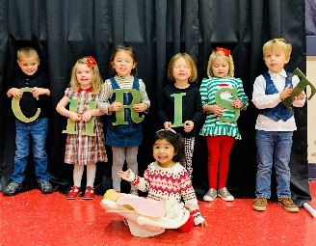
About My K3 Program:
The K3 program at Hickory Valley Christian School is a comprehensive program that includes both academic learning i.e. Reading and Math, Science and Social Studies, Art and STEM building, Bible and Music, Writing, Cooking and Gardening, Home Economics, and so much more!
In order to encourage our children in their walk with God, I teach Bible on a daily basis.
Each month we study a Unit in which we learn about anything and everything from Weather to Dinosaurs…depending on the child’s interests! My goal is to provide an environment that is conductive to the children’s learning, the blossoming of their imaginations, and of course a great deal of FUN!
My goal at HVCS is to inspire the WHOLE child. I hope you join HVCS for many more years of excitement and learning as we love having you a part of our HVCS family!
Our Activities:
My goal is to create lesson plans that will both educate and inspire the children to participate, where I meet the child’s individual needs. This can include anything from letter songs to number and counting games. To accommodate the length of the attention span and keep the children both active and interested, I move quickly from one activity to another. Art projects are designed to be fun and developmental in regards to fine motor skills, while physical games and play develop the gross motor skills. I like to encompass a bit of everything in K3 for a well-rounded curriculum.
After all, our school’s mission statement is, “Building a Strong Foundation,” and I will do my best to help build a strong foundation for every child who enters my classroom as it is my duty as their teacher and an educator to love them, teach them all the things they need to know at their young age, and make sure they feel safe and secure during the school day.
May the Lord bless you and keep you,
Mrs. Kelsey

